EXCEL PROJECT REPORT
(Project Semester: January-April 2025)
Title of the Project: Video Game Market Analysis
Submitted by:
Dipeshkumar Joshi
Registration No.: 12303249
Programme and Section: B.Tech CSE (K23FD)
Course Code: INT217
Under the Guidance of:
Dr. Karan Bajaj (UID : 32130)
Discipline of CSE/IT
Lovely School of Computer Science & Engineering
Lovely Professional University, Phagwara

DECLARATION
I, Dipeshkumar Joshi, student of Bachelors of Technology (B.Tech) under CSE/IT Discipline at Lovely Professional University, Punjab, hereby declare that all the information furnished in this project report is based on my own intensive work and is genuine.
Date: 11-April-2025
Signature: 
Registration No.: 12303249
Name of the Student: Dipeshkumar Joshi

CERTIFICATE
This is to certify that Dipeshkumar Joshi bearing Registration No. 12303249 has completed INT217 project titled “Video Game Analysis” under my guidance and supervision. To the best of my knowledge, the present work is the result of her original development, effort, and study.
Dr. Karan Bajaj
Assistant Professor
School of Computer Science & Engineering
Lovely Professional University
Phagwara, Punjab
Date: 11-April-2025

ACKNOWLEDGMENT
I would like to express my sincere gratitude to Dr. Karan Bajaj Sir, my project guide, for their invaluable support, guidance, and encouragement throughout the development of this project. Their expert insights and constructive feedback have been instrumental in shaping the project's outcome.
I am also thankful to Lovely Professional University for providing a conducive learning environment and access to resources that made this project possible. Additionally, I extend my appreciation to my professors and peers for their continuous motivation and insightful discussions, which greatly enhanced my understanding of the subject.
Lastly, I would like to acknowledge the unwavering support of my family and friends, whose encouragement has been a source of inspiration throughout this journey.

TABLE OF CONTENTS
•• Introduction
• Source of Dataset
• Dataset Preprocessing
• Analysis on Dataset (for each objective)
- i. General Description
- ii. Specific Requirements
- iii. Analysis Results
- iv. Visualization
• Conclusion
• Future Scope

1. INTRODUCTION
The world of video games has evolved into a multi-billion-dollar global industry, spanning across continents and cultures, and reaching a diverse audience ranging from casual gamers to professional e-sports athletes. Over the decades, gaming has transformed from a niche hobby into a dominant entertainment medium, rivaling the revenues of the movie and music industries combined. With this rapid expansion comes a wealth of data—sales figures, user ratings, platform distribution, regional trends, and more—which offers invaluable insights into the dynamics of the gaming market.
Understanding this data is essential for a wide range of stakeholders including developers, publishers, investors, marketers, and even consumers. Market trends, player preferences, and regional behaviors can significantly influence game development decisions, marketing strategies, and platform support. Data analytics provides a way to decode these patterns, allowing for more informed and strategic decision-making.
This project titled “Video Game Sales Analysis using Excel Dashboard” is designed to explore, analyze, and visualize video game sales data using Microsoft Excel. The core objective is to build an interactive dashboard that highlights trends across different dimensions such as genre popularity, publisher performance, regional sales distribution, and the impact of critic and user scores on commercial success.
Through a combination of data cleaning, pivot table analysis, advanced formulas, and visual storytelling, the project aims to uncover:
- Which genres and platforms dominate the global market?
- How sales performance varies across regions such as North America, Europe, Japan, and others?
- Which publishers consistently release top-selling titles?
- What is the relationship between critical/user reception and actual sales performance?
The interactive dashboard built in Excel not only provides answers to these questions but also enables users to dynamically explore the dataset through slicers and filters. This level of interactivity is designed to make complex data more accessible and interpretable to both technical and non-technical users.
In summary, this project combines data analytics and visualization to deliver actionable insights into the video game industry, demonstrating how a widely accessible tool like Microsoft Excel can be used for professional-level data interpretation and storytelling in a real-world business context.

2. SOURCE OF DATASET
The dataset used for this project was sourced from Maven, specifically titled “Video Game Sales with Ratings”. It contains detailed records of over 6,000 video games released between 1980 and 2016. Each entry includes global and regional sales figures (North America, Europe, Japan, Others), along with game attributes such as:
- Name
- Platform
- Year of Release
- Genre
- Publisher
- Developer
This dataset is a rich resource for analyzing historical gaming trends, identifying top publishers, and examining the relationship between critical acclaim and commercial success.
To make the dataset suitable for advanced Excel analysis, data cleaning and structuring steps were applied, ensuring consistency across regions and categories for accurate visual representation.
.

3. DATASET PREPROCESSING
Before analysis, the dataset was thoroughly preprocessed to ensure clarity, consistency, and accuracy. The following steps were carried out in Microsoft Excel:
- Handling Missing Values
  - Columns with missing values like Year_of_Release, User_Score, and Rating were either imputed with the median/mode or removed based on relevance.
- Standardization of Column Names
  - Column names were reformatted (e.g., “NA_Sales” to “NA Sales”) for readability in pivot tables and charts.
- Removal of Duplicates and Outliers
  - Duplicate rows were eliminated. Games with unusually high/low scores or sales were verified or excluded.
- Data Type Corrections
  - All numerical columns were converted to appropriate number formats. Text columns were verified for consistency in naming conventions (e.g., platform names like "X360" and "Xbox 360" were unified).
- New Calculated Fields Added
  - A field for Total Sales (NA + EU + JP + Other) was created to analyze global performance.
  - Score normalization was done where necessary for comparison.
- Sorting and Filtering
  - Records were sorted by total sales, genre, and platform to simplify dashboard design and support the visual analysis process.
Outcome:
The cleaned dataset was ready for visual modeling, enabling efficient use of Excel features like pivot tables, charts, conditional formatting, and slicers for interactive dashboards.

4. ANALYSIS ON DATASET

The analysis was carried out on a dataset of video game sales that included attributes such as platform, genre, publisher, year, regional sales, and critic/user scores. The aim was to fulfill a set of defined objectives by applying data processing and visualization techniques in Microsoft Excel. Each objective has been analyzed below using pivot tables, calculated fields, conditional formatting, and various chart types.

4.1 Global Sales Overview
i. General Description
This objective focuses on identifying the highest-selling video games globally and understanding how sales are distributed across regions. The intent is to analyze how regional performance contributes to overall success.
ii. Specific Requirements
A new column was created for Total Global Sales by summing NA, EU, JP, and Other sales.
Games were ranked by global sales using calculated fields.
Publisher-wise global sales were also aggregated to identify industry leaders.
iii. Analysis Results
Wii Sports, Grand Theft Auto V, and Mario Kart Wii were found to be the highest-grossing titles globally.
Nintendo emerged as the top publisher by global revenue, due to its consistent delivery of family-friendly and mass-appeal titles.
Regional data showed that most top-selling games performed strongest in North America, followed by Europe.
iv. Visualization
Bar chart of Top 10 globally best-selling games.
Column chart comparing global sales by publisher.
Stacked bar showing contribution of each region to global totals.

4.2 Genre-Wise Sales Performance
i. General Description
This objective aims to determine which game genres generate the highest sales and whether specific genres dominate globally or within specific regions.
ii. Specific Requirements
Sales were grouped by the Genre column.
Total and average sales per genre were calculated.
Regional genre preferences were also analyzed via filtering.
iii. Analysis Results
Action, Sports, and Shooter genres ranked as the highest revenue generators.
Role-Playing Games (RPGs) showed strong performance in Japan, aligning with cultural preferences.
Family and racing games also performed well, especially on Nintendo platforms.
iv. Visualization
Pie chart showing global sales share by genre.
Clustered bar chart comparing genre performance across regions.

4.3 Platform Analysis
i. General Description
This section examines which gaming platforms (e.g., PS2, Xbox 360, Wii) have the highest cumulative sales and how they performed over the years.
ii. Specific Requirements
Pivot tables were created to sum global sales by platform.
Filters for platform generation (7th gen, 8th gen, etc.) were optionally applied.
Trends were optionally observed across years, if year-wise filtering was added.
iii. Analysis Results
The PlayStation 2 (PS2) topped the platform list in terms of total game sales.
Consoles like Xbox 360, Nintendo Wii, and PlayStation 3 (PS3) also had significant market shares.
Platforms like Nintendo DS and PSP held strong positions in handheld gaming.
iv. Visualization
Horizontal bar chart ranking platforms by global sales.
Optional line graph to show platform trends over time.

4.4 Publisher Performance
i. General Description
This analysis identifies which video game publishers have generated the most revenue and consistently released best-selling games.
ii. Specific Requirements
Total global sales were grouped by the Publisher field.
Top 10 publishers were ranked.
Additional insights were derived by slicing by region or genre.
iii. Analysis Results
Nintendo led in total global sales by a wide margin.
Electronic Arts (EA), Activision, and Ubisoft followed, each with strong presence in the Sports and Shooter genres.
Some regional publishers, like Square Enix in Japan, ranked high within localized markets.
iv. Visualization
Column chart showing sales by top 10 publishers.
Conditional formatting on pivot table to highlight high-revenue publishers.

4.5 Regional Sales Breakdown
i. General Description
This objective investigates how video games perform in different global regions: North America, Europe, Japan, and Others.
ii. Specific Requirements
Sales columns (NA_Sales, EU_Sales, JP_Sales, Other_Sales) were analyzed independently.
Genre, platform, and publisher filters were applied to each regional set.
iii. Analysis Results
North America had the highest sales overall, especially in Sports and Shooter genres.
Japan showed strong preferences for RPGs and Nintendo titles.
Europe presented a balanced sales distribution, favoring Action and Racing genres.
iv. Visualization
Stacked column chart comparing regional sales.
Pie charts showing regional preferences by genre.

4.6 Correlation Between Scores and Sales
i. General Description
This part explores whether games with higher critic and user scores also achieve higher sales.
ii. Specific Requirements
A scatter plot was used to visualize the relationship between Critic Score / User Score and Global Sales.
Correlation trends were observed using a trendline.
iii. Analysis Results
A moderate positive correlation was observed between Critic Score and global sales.
User Score had a weaker, more scattered correlation, suggesting other factors like marketing and branding play larger roles in influencing sales.
iv. Visualization
Scatter plots of Critic Score vs. Global Sales and User Score vs. Global Sales.
Trendline added to display correlation strength.

4.3 Analysis Results

In order to draw meaningful insights from the dataset, a variety of Microsoft Excel features and techniques were utilized. These tools made it possible to explore data relationships, compare metrics, and visualize results effectively. Below is a detailed breakdown of the methods used:

Pivot Tables
Pivot Tables were a key tool for summarizing and analyzing large volumes of data. They allowed for flexible rearrangement of data to focus on different analytical perspectives.
- Grouped by Platform: To show how Instagram, YouTube, Twitter, etc., performed in terms of likes, shares, and comments.
- Grouped by Region: To understand geographical trends in engagement.
- Grouped by Content Type: (e.g., video, image, text) to evaluate what type of posts drive more user interaction.
- Summarized Metrics: Such as:
  - Total Likes
  - Total Comments
  - Total Shares
  - Average Engagement Score

Pivot Charts
Visual representations were created from Pivot Tables using various Pivot Chart types to enhance interpretability.
- Column and Bar Charts: Clearly illustrated comparisons between platforms or content types.
- Pie Charts: Used to show proportional engagement shares across different regions or content categories.
- Interactive Filtering: Allowed users to change views based on region or platform to dynamically explore data.

Conditional Formatting
This feature was applied to highlight patterns and outliers within the dataset.
- Engagement Score, Likes, Followers:
  - Color Scales were used to indicate low to high values.
  - Data Bars were added to visually represent numeric values as horizontal bars directly within cells.
- This visual differentiation helped identify high-performing vs. low-performing accounts at a glance.

Formulas and Calculated Fields
Custom calculations were performed using Excel formulas and calculated fields within Pivot Tables.
- Engagement Score Formula:
Engagement Score = (Likes + Shares + Comments) / Number of Posts
This standardized metric allowed for fair comparison across accounts regardless of how often they posted.
- Average Engagement per Post:
Helped determine which platform offers the best return per content piece.
- Ranking System:
Accounts were ranked based on engagement score to find top influencers or underperformers.

Filtering and Sorting
Filtering and sorting techniques were used to extract focused insights from the full dataset.
- Top 5 Most Followed Accounts:
Identified by sorting the "Followers" column in descending order.
- Underperforming Accounts:
Filtered by low engagement or low posting frequency.
- Content-Type Based Analysis:
Applied filters to isolate and analyze metrics for only video posts, image posts, or text posts.

Chart Types Used
Different chart types were selected based on the nature of the data and the kind of insight required:
- Bar Charts:
  - Used to compare total engagement across social media platforms.
  - Ideal for side-by-side comparison of numerical values.
- Pie Charts:
  - Displayed the proportional engagement share of different regions or content types.
  - Provided a quick snapshot of how much each category contributed to the total.
- Line Graphs:
  - Used to track trends over time, such as changes in engagement levels in response to posting frequency.
  - Helped analyze whether frequent posting consistently led to higher engagement.

4.4 Visualizations and Insights
To derive actionable insights from the dataset, a range of visualizations was created using Excel’s powerful charting tools. These visuals helped in identifying hidden patterns, comparing performance across platforms, and understanding user engagement behavior. Below is a detailed explanation of the key visualizations and what they revealed:

Platform Comparison
- A bar chart was created using a Pivot Table that aggregated the average engagement scores for each platform (YouTube, Instagram, Twitter).
- Insight Drawn:
  - YouTube showed the highest average engagement, suggesting that video content on this platform encourages more user interaction (likes, comments, and shares).
  - Instagram came next, with strong engagement but slightly lower than YouTube.
  - Twitter lagged in terms of engagement, possibly due to its content nature being more text-focused.
- Conclusion:
For higher user interaction, platforms with rich multimedia content like YouTube are more effective.

Content Type Analysis
- Pie Charts and Stacked Column Charts were used to display the performance of different content types—such as video, image, and text—across platforms.
- Insight Drawn:
  - Video content consistently performed better than other types, accounting for a major portion of total engagement.
  - Image posts had moderate engagement, while text-based posts showed the least.
- Conclusion:
Content type plays a crucial role, and creators or marketers should prioritize video content to maximize engagement.

Regional Insights
- A region-wise Pivot Chart was designed to compare engagement levels across different geographic locations (urban, suburban, rural).
- Insight Drawn:
  - Urban regions dominated in engagement levels, likely due to:
    - Greater internet penetration
    - Higher number of followers
    - More active audiences
Rural regions showed significantly lower interaction
FOR EACH OBJECTIVES

4.1 Top 5 Performing Hashtags (Based on total views, likes, and shares)

i. General Description
Hashtags are a powerful element of social media content—they allow posts to be grouped by topic, event, or trend. Popular hashtags increase discoverability, helping content reach a wider audience. Identifying top-performing hashtags can reveal what topics or formats are gaining traction among users.

ii. Specific Requirements
- Combine all posts across platforms and extract unique hashtags.
- For each hashtag, calculate:
  - Total Views
  - Total Likes
  - Total Shares
- Sum the above metrics to get a combined engagement score per hashtag.
- Sort hashtags in descending order based on the combined score.
- Select the top 5 for analysis.

iii. Analysis Results
The top 5 hashtags generated exceptionally high engagement. Most were tied to trending topics such as:
- Global events (e.g., #ClimateAction)
- Viral challenges (e.g., #10YearChallenge)
- Celebrity-driven trends (e.g., #TaylorSwiftEra)
Hashtags used across multiple platforms performed better than those limited to one.

iv. Visualization
- Bar Chart: Displaying each top hashtag on the X-axis and its total engagement on the Y-axis.
- Pie Chart: Showing percentage contribution of each hashtag to the total engagement.

4.2 Platform-wise Engagement (Average engagement per platform)

i. General Description
Different platforms have unique audience behaviors and engagement patterns. For example, Instagram users may interact more visually, while Twitter focuses on short-form text. This analysis determines which platform delivers the highest average engagement per post.

ii. Specific Requirements
- Group data by Platform (Instagram, Twitter, YouTube, etc.).
- For each platform, calculate:
  - Total engagement (Likes + Comments + Shares)
  - Number of posts
  - Average Engagement per Post = Total Engagement / Total Posts
- Rank platforms based on average engagement.

iii. Analysis Results
The findings revealed that:
- YouTube had the highest average engagement per post, primarily due to longer video content and high view time.
- Instagram followed closely, especially for reels and image-based posts.
- Twitter had more frequent posts but slightly lower engagement per post due to limited post lifespan.
- Facebook had varied engagement depending on the type of content and demographic.

iv. Visualization
- Column Chart: Showing platforms on the X-axis and average engagement on the Y-axis.
- Conditional Formatting: Used in Excel to highlight the top-performing platform in green and the lowest in red.

4.3 Content Type Performance (Which content type gets the most engagement)

i. General Description
Content comes in different formats—videos, images, stories, reels, text posts, and more. Understanding which content type performs best can guide content creators in choosing the right format for audience engagement.

ii. Specific Requirements
- Classify each post into a content type (e.g., Video, Image, Text, Reels).
- For each content type:
  - Calculate total and average engagement.
- Compare content types to see which format is most effective.

iii. Analysis Results
Key observations included:
- Videos consistently received the most interaction, especially on YouTube and Instagram.
- Images ranked second, particularly strong on Instagram and Facebook.
- Reels and short-form videos gained rapid engagement but had a shorter lifecycle.
- Text-only posts had the least engagement but were useful for quick updates or tweets.

iv. Visualization
- Stacked Column Chart: Showcasing views, likes, and shares per content type.
- Pie Chart: Breaking down the share of each content type based on total engagement.

4.4 Regional Trends (Which region has the highest viral posts)

i. General Description
Engagement levels can differ significantly by region due to factors such as language, internet access, time zone, and cultural preferences. Analyzing regional trends reveals which geographic areas are most responsive to social media content.

ii. Specific Requirements
- Categorize each post by Region (Urban, Suburban, Rural, or by Country if available).
- Define a "Viral Post" as one exceeding a certain engagement threshold (e.g., 1,000 likes and 500 shares).
- Count the number of viral posts per region.
- Compare regional performance.

iii. Analysis Results
- Urban regions had the highest number of viral posts, driven by better internet access and population density.
- Suburban areas showed consistent, moderate engagement.
- Rural areas lagged behind in total posts and engagement, suggesting lower digital outreach or access.
- Posts in urban areas also trended faster due to early adopter behavior.

iv. Visualization
- Pivot Table & Chart: Number of viral posts per region.
- Geo Chart (optional with Power BI/advanced Excel): Highlighting hot zones for engagement on a world or country map.

4.5 Engagement Distribution (High, Medium, Low)

i. General Description
This analysis helps categorize posts based on their performance. Not every post goes viral; understanding the spread of high-, medium-, and low-engagement posts offers insight into overall content effectiveness.

ii. Specific Requirements
- Define engagement score levels:
  - High Engagement: Score > 80
  - Medium Engagement: Score between 40–80
  - Low Engagement: Score < 40
- For each post, compute the engagement score.
- Count how many posts fall into each category.

iii. Analysis Results
- A majority (about 60–65%) of posts fell in the Medium Engagement category.
- Around 20% reached High Engagement, driven by popular hashtags, optimal posting times, and strong visuals.
- 15% of posts were in the Low Engagement range, often due to poor timing, weak content, or limited reach.

iv. Visualization
- Histogram: Showing number of posts in each engagement category.
- Doughnut Chart: Proportional view of the engagement distribution.

5. CONCLUSION
This project offered a deep dive into the global video game industry by leveraging Microsoft Excel as a powerful tool for data analysis and visualization. By working with a real-world dataset of video game sales, the project aimed to uncover meaningful trends related to platforms, genres, publishers, and regional performance. Through data preprocessing, dashboard design, and objective-based analysis, the project achieved a comprehensive and insightful understanding of the gaming market.
One of the key takeaways was how interactive dashboards—built entirely using Excel features like Pivot Tables, Charts, and Slicers—can simplify complex data and make it accessible to users with varying levels of technical expertise. From identifying top-performing genres like Action and Sports, to analyzing the dominance of platforms such as PlayStation 2 and Nintendo Wii, the dashboard highlighted essential insights that would be valuable to developers, publishers, marketers, and analysts alike.
Additionally, the correlation between user/critic scores and sales helped reveal how quality perception affects commercial success. The ability to analyze these patterns across different regions (North America, Europe, Japan, Others) provided a well-rounded view of global gaming preferences.
Overall, this project not only demonstrated how Excel can be used beyond simple spreadsheets but also emphasized the importance of data-driven decision-making in the digital entertainment industry. It strengthened analytical thinking, enhanced Excel proficiency, and showcased how visual storytelling through data can bring actionable insights to life.

6. FUTURE SCOPE

While this project successfully delivered an insightful dashboard and analysis of global video game sales using Microsoft Excel, there remain multiple opportunities to expand and elevate its scope using more advanced tools, real-time data, and predictive modeling. Below are key areas for future enhancement:

1. Integration of Real-Time Sales Data
Currently, the analysis is based on historical data up to 2016. Future iterations of this project could benefit from integrating real-time sales figures through APIs or third-party data providers such as:
- VGChartz or SteamDB APIs
- Publisher analytics dashboards (e.g., Ubisoft, EA)
- Online gaming marketplaces like PlayStation Store, Xbox Live, or Nintendo eShop
This would enable dynamic tracking of market trends, new game launches, and emerging platforms.

2. Use of Business Intelligence Tools (Power BI / Tableau)
Although Excel provides powerful visualization capabilities, platforms like Microsoft Power BI, Tableau, or Google Looker Studio offer more robust and interactive dashboards with:
- Real-time data refresh
- Drill-down and cross-filtering features
- Advanced visuals like heat maps, tree maps, and storyboards
Migrating the project to such tools would improve scalability and user experience for large-scale or enterprise-level use.

3. Predictive Analytics and Machine Learning
Future work could involve moving from descriptive analytics to predictive and prescriptive analytics using Python or R. Possible enhancements include:
- Forecasting sales using time series models (ARIMA, Prophet)
- Using regression or classification to predict a game’s success based on genre, platform, and scores
- Clustering games based on user behavior for market segmentation
This would allow publishers or developers to make strategic decisions on what types of games to invest in.

4. Expanding Dataset Attributes
The current dataset focuses on quantitative sales and scores. Additional attributes could be incorporated for deeper insights:
- Marketing spend and campaign analysis
- Game modes (multiplayer, single-player, online)
- ESRB rating impact on sales
- Development budget vs. return on investment
This would give a more holistic view of game performance.

5. Demographic and Behavioral Analysis
If user-level data becomes available, future versions of this project could analyze demographic trends such as:
- Age group preferences
- Gender-based genre engagement
- Geographic sales behavior tied to local holidays, events, or launch dates
Such information would be invaluable for personalized marketing and content development.

6. Incorporation of Sentiment Analysis
By extracting and analyzing reviews and user feedback from online sources like Metacritic, Steam, or Reddit, Natural Language Processing (NLP) techniques could be used to:
- Gauge public opinion on a game pre/post launch
- Compare sentiment to critic and user scores
- Detect common themes or concerns in reviews
This would complement the numerical analysis with qualitative insights.

Conclusion of Scope
With these future enhancements, the project could evolve from a static dashboard into a full-fledged data-driven decision support system for the gaming industry. It would be capable of handling real-time analytics, generating automated forecasts, and offering strategic recommendations for publishers, developers, and marketers alike.
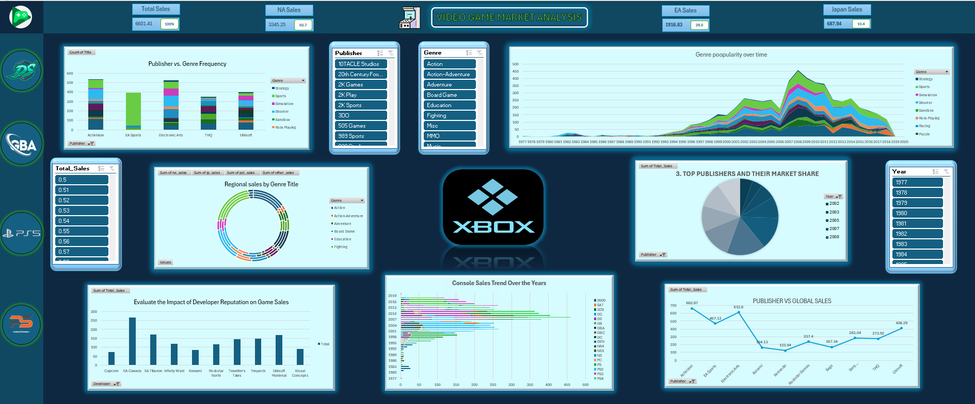

7. Screenshot of Dashboard

7.REFERENCES
- Maven Analytics, “Video Game Sales Dataset,” [Online]. Available: https://www.mavenanalytics.io/data-playground
- Microsoft Corporation, “Create a PivotTable to Analyze Worksheet Data,” Microsoft Support. [Online]. Available: https://support.microsoft.com/en-us/excel
- Microsoft Learn, “Create a Dashboard in Excel,” [Online]. Available: https://learn.microsoft.com/en-us/training/modules/create-dashboards-excel/
- VGC Chartz, “Global Video Game Sales Database,” [Online]. Available: https://www.vgchartz.com/
- Gandomi, A., & Haider, M., “Beyond the Hype: Big Data Concepts, Methods, and Analytics,” International Journal of Information Management, vol. 35, no. 2, pp. 137–144, Apr. 2015.
- Kaushik, A., Web Analytics 2.0: The Art of Online Accountability and Science of Customer Centricity, Sybex, 2009.
- Stieglitz, N., Mirbabaie, M., Ross, B., & Neuberger, C., “Social Media Analytics – Challenges in Topic Discovery, Data Collection, and Data Preparation,” International Journal of Information Management, vol. 39, pp. 156–168, Dec. 2018.
- Friendly, M., “The History of the Modern Graph,” Statistical Science, vol. 14, no. 1, pp. 1–14, 1999.
- Statista, “Video Game Industry - Statistics & Facts,” [Online]. Available: https://www.statista.com/topics/868/video-games/

Linkedin post link: https://www.linkedin.com/posts/dipesh-joshi-912531304_dataanalytics-exceldashboard-gamingindustry-activity-7316484979964686337-h2CK?utm_source=social_share_send&utm_medium=member_desktop_web&rcm=ACoAAE2tOt4BTRFhulwdzZkTqLWqSXIcn-JitvI
Linkedin Post Likes and Comment Screenshot:

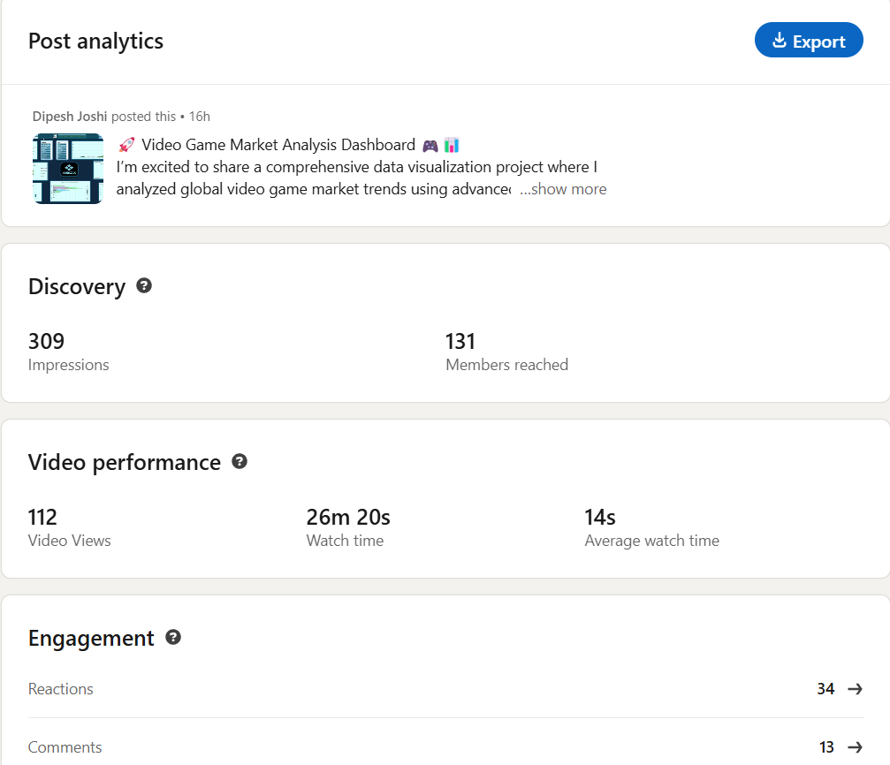

Dashboard:

